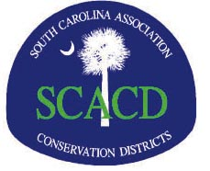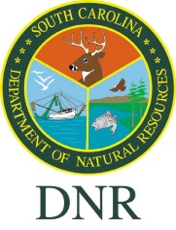

**2024 SC Partnership Conference**

On behalf of the SC Association of Conservation Districts (SCACD), I would like to invite you to be a sponsor at our 2024 Partnership Conference. It will be held in Myrtle Beach, South Carolina on January 22-24, 2024, at the Embassy Suites.

We are attentively working on bringing knowledgeable information to our Districts’ leadership and our partners. Our partners include USDA/NRCS, SC Department of Natural Resources, SC Farm Bureau, SC Forestry Commission, and others. The conference includes two days of sessions on conservation issues. There will be many opportunities for you to network and socialize with the group.

It would be a wonderful opportunity for your organization to be in front of an audience of conservation professionals with backgrounds varying from agriculture to urban natural resource management.

We invite you to be a partner with us at this conference.

Jeff Wilson

SCACD President



**2024 SC Partnership Conference**

**Exhibitor/Sponsor Application Form**

Please complete this form and return with a check made payable to SCACD.

Mailed to: SCACD, 5 Geology Road, Columbia, South Carolina 29212

Note: Information must be received by Monday, January 1, 2024

to have your logo included in program.

Enclosed is my check in the amount of $___________

Company/Agency Name_______________________________________________________________

Contact Person______________________________________________________________

Address (City, State, Zip)_____________________________________________________

Phone ______________________ Email ___________________________________________

_______ YES, I will need one exhibitor table.

_______ NO, I will have a freestanding exhibit.

_______ Sponsorship only, I will not be attending the Conference.

Will there be a representative to man the booth? YES NO

If Yes,

Name_______________________________ Title __________________________________

Will you need an electrical outlet at your display? YES NO

What will you display/distribute? _____________________________________________

**NOTE TO EXHIBITORS**

***Exhibitors will be admitted to the exhibit hall for set up at 11:00 a.m. Monday, January 22, 2024 at the Embassy Suites, Myrtle Beach. Exhibits must be removed no later than 12 p.m. Wednesday, January 24, 2024.*** *Security will be provided for tables and displayed items during the conference. Exhibitors shall hold harmless hotel and its serving agents from all liability (damage or accident) which ensure from any cause resulting or connected with transportation, placing, removal or display of exhibits.*

